USS TUNNY
(SS, SSG, APSS, LPSS 282)
A History, Tribute, and Memoir
~
Researched and written
by

Raymond Vance Olszewski
Boat Yeoman
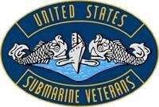
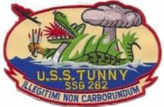
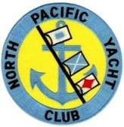
USS Tunny (SSG 282) 1958-1962
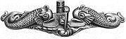
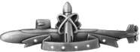

Qualified in Submarines 24 September 1959 |  | Veteran of Five  Regulus Deterrent Patrols
National Life Member | SSG Era Veteran |  | NPYC  Member
Diesel Boats Forever

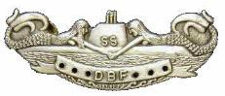
©2018

Self-Published by Olszewski Enterprises Printed in the USA

Chapter Ten - The Genesis of Tunny's Mascot
“How would you like it if someone called you at 5:30 in the morning and told you that your Maneuvering Room was flooding?” --Marvin Smith Blair, CO, USS Tunny (SSG 282)

“Hell, I couldn’t get out of my submarine at that time in the morning!”--Edward
Dietrick Franz, CO, USS Ronquil (SS 396)

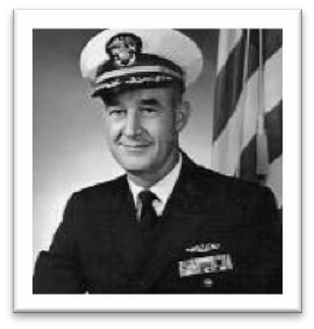
This verbal diatribe took place on the deck of the Tunny (SSG 282) while the sub was moored at Pier S-1A at the Pearl Harbor Submarine Base. It was about noon on Friday, 17 April 1959. An enraged Captain Franz (San Bernardino, California), Commanding Officer of the Ronquil (SS 396), along with his executive officer, Don Whitmire (Pulaski, Tennessee), Chief of the Boat, Andrew Loftis (Fresno, California) and many of his crew had walked across the submarine base from where Ronquil was moored to the Tunny. When they arrived at the gangway, Tunny’s Topside Watch announced over the sub’s 1MC system, “RONQUIL, RONQUIL!” Within seconds, Tunny crewmembers, led by Captain Marvin Blair, gathered topside to confront the Ronquil’s delegation.
Without a friendly hello, handshake, or even a salute, Captain Franz (shown) began demanding that Captain Blair return his panther to him “immediately.” A brief argument followed between the two COs, with Blair telling Franz that he did not have it. Captain Blair, while shaking his fist under both the Ronquil’s CO and XO’s noses, told them to “get off of his boat immediately, or he would wipe up the deck with them.” Franz and the rest of the Ronquil's delegation left the Tunny’s deck. While standing on the pier near the gangway, Franz hollered back to Captain Blair, “I want my panther returned before I set sail today!” Adding, “And, I want it returned unharmed!”
What Franz wanted was a metal statue of a panther, the Ronquil’s mascot, which a small band of Tunny crewmembers had successfully liberated from its welded mount on the sub’s superstructure earlier that day. This was accomplished while Ronquil’s entire crew was secured below in their submarine by a handful of Tunny crewmembers, which was not only a security breach, but embarrassing as well. This act would appear to be somewhat juvenile, perhaps on the level of a high school or college prank, but it soon turned into something more serious that resulted in at least one individual losing his job, along with COMSUBPAC's promulgation of an edict to stop the practice of stealing submarine mascots.
In the 1990s, I wrote an article, “The Submarine vs. the Panther,” a collection of my personal memories of the incident that I had participated in along with a few former Tunny shipmates. I sent the article to the editor of the American Submariner magazine for consideration to be published and shared with the USSVI.org members. The article ended up published in the May- June 2000 issue, and I received some feedback and comments from some of those who were part of the small band and Captain Blair, himself. His comments provided me with the “rest of the story.” What follows is an updated version of the original article.

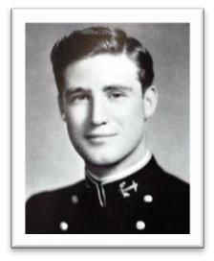
The Ronquil (SS 396), a Balao-Class submarine, departed from its home port of San Diego, California, on 6 April 1959, headed for the Kuril Islands in the northwestern Pacific Ocean where it would collect intelligence about the movements of the Soviet Navy in and out of the ports of Vladivostok and Petropavlovsk. This was a very serious mission. Ronquil and its crew of about 80 officers and men were under the command of Captain Edward Dietrick “Pat” Franz, USN, who had relieved Commander Harold Albert “Hal” Taylor, USN (Jackson, Michigan) (shown as a Naval Academy Midshipman, Class of 1945), in June of 1955. Sometime during his tenure as CO of the Ronquil, Taylor
had gifted a statue of a panther figure to symbolize its crew, who were known as “Taylor’s Tigers.” According to Patrick “X” Franz, a son of Edward Franz, his father was known by his friends and acquaintances as “Pat” because he had been born on Saint Patrick’s Day. Under Franz’s command, the Ronquil crew became known as “Pat’s Panthers.”

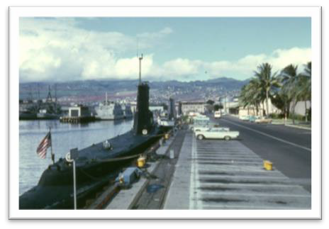
The trip to the Kurils from San Diego was about 4,500 nautical miles, so a brief stop at Pearl Harbor to load fuel and fresh provisions would be necessary.
The sub’s leadership would probably meet with Rear Admiral Elton Watters Grenfell, USN, who was Commander Submarine Force, U.S. Pacific Fleet. On 14 April 1959, the Ronquil moored at Pier S-11 at Pearl Harbor, where it would remain for a few days before starting its five-month-long deployment to the Western Pacific (WESTPAC). The inserted picture is an unidentified fleet diesel submarine moored to Pier S-11 along North Waterfront Street at the Submarine Base (Sub Base), Pearl Harbor.
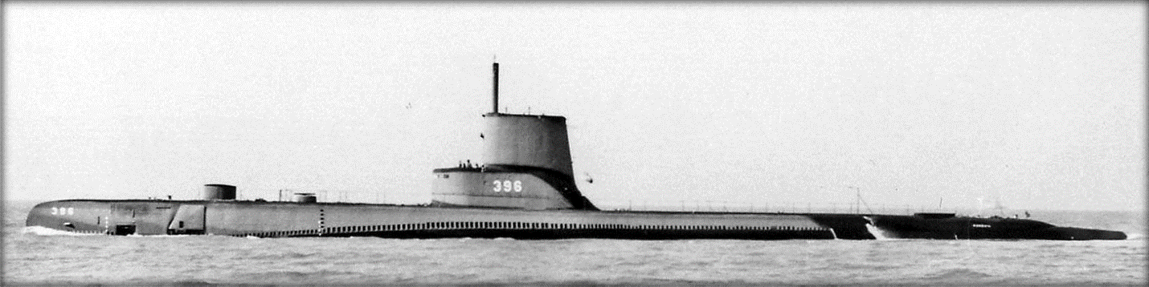
Photo above is the Ronquil (SS 396) taken in early 1950s when she had a “step sail” configuration. It was later changed to a “high sail.”
The Sub Base at Pearl Harbor has supported submarines and their crews since the early 1900’s. According to one Internet source, the first submarines (Four F-Class) were stationed at Pier 5 in the downtown Honolulu Harbor well before the submarine base at Pearl was completed. During World War II, submarines serviced by the Pearl Harbor Submarine Base made 488 war patrols from Hawaii, sinking a total of 2,009,744 tons of enemy shipping. Over the years, Sub Base Pearl has seen much in the way of changes since it was first established in the early 1920’s. Its mission has remained the same - to provide support to the submarines and their crews, regardless

of their home port. The photograph is of the stretch of wharves located on North Waterfront Street at the Submarine Base, Pearl Harbor, Hawaii; this was where Ronquil had moored in April 1959.
By 1959, the Sub Base at Pearl Harbor was a home away from home for several hundred submariners, offering more comfortable and roomier quarters than what the boats had to offer. Besides the excitement that the submarine service offers, rewards for submarine crews who volunteered for hazardous submarine duty were found in the form of extra pay, good food, and serving with shipmates who had an unusually high level of morale and camaraderie. Oh yes, and a clean place to sleep.
One of the rewards provided a Pearl Harbor-based submariner was found in the center of the approximate 125-acre Pearl Harbor Sub Base. It was the enlisted men’s barracks. The barracks building was a large four-story facility that stood in the middle of the small and industrious base.
The barracks were originally built in 1928 for submariners and base support personnel who didn’t live off base with their families. Permanently based submarines each had an assigned section inside the barracks. They were used by the submariners while in port and when they were not assigned to a duty section, which had to remain onboard their boats when they had the "duty." Along with large shower facilities, each submariner had his own bunk and a storage locker.
In 1959, a chow hall was located on the lower level of one end of the barracks. On the opposite end, base security personnel occupied a small security office that included an iron-barred brig large enough to hold about half-dozen men, standing up. The submarine base also had an enlisted men’s club, Beeman Center, named in memory of Chief Pharmacist’s Mate Arthur C. Beeman (Memphis, Tennessee), who lost his life on the bridge of the Amberjack (SS 219) during World War II. He was posthumously awarded a Bronze Star medal for his heroic actions in February 1943. A Chief’s Club was situated near the Beeman Center and the enlisted barracks.
On Ronquil, next in command under Lieutenant Commander Franz was Ronquil’s executive officer and navigator, Lieutenant Donald Boone “Big Daddy” Whitmire, USN. Ronquil’s Chief of the Boat (COB) was World War II veteran Fire Control Technician (FTC) Andrew Loftis, USN. The duties of submarine COBs included managing and directing the activities and duties of the submarine’s enlisted crewmembers. They also served as the senior enlisted advisor to the submarine’s commanding and executive officers. Submarine COBs have a tremendous amount of authority, and a key function of the COB’s job is to assist the CO and XO in matters regarding the crew’s good order and discipline. Additionally, he is responsible for the day-to-day operations and the morale and training of the boat’s enlisted personnel. When a new enlisted sailor joins the boat’s crew, the COB is usually one of the first people the sailor meets when he reports aboard the submarine for duty.
The day that the Ronquil arrived at Pearl from San Diego Tunny Quartermaster Third Class, Donald R. Freeman, was transferred from the Tunny to the Ronquil (SS 396) to join their WESTPAC deployment. Freeman, who is on the right in the photo shown on the next page, played a part in the Panther’s requisitioning. Tunny Guided Missileman Duaine Truman Edwards is on the left. He had nothing to do with the escapade and just happens to be in the only photo found for Freeman.

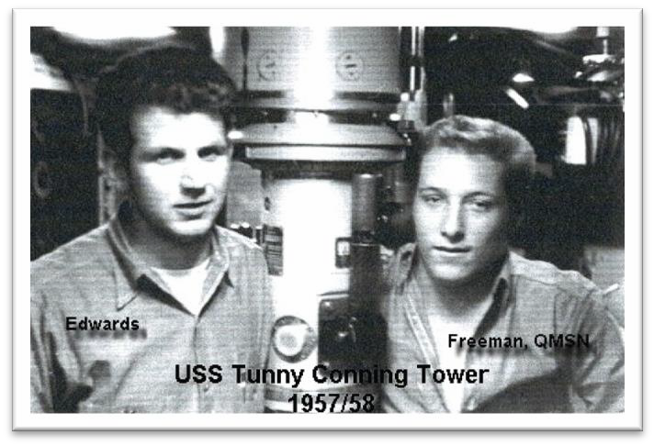
According to one Internet source, “The submarine base at Pearl Harbor has been host and home port to many notable submarines during the 1950’s and early 1960’s, and Wharfs S13 to S19 have been the site of some historic events.” One of these mentioned by the source took place on 13 May 1957 when the “submarine SSG 282, USS Tunny, arrived at the submarine base to begin a tour of deterrent patrols and exercises, using Pearl Harbor as her home port.”
In April 1959, the commanding officer
of the Tunny was Lieutenant Commander Marvin Smith Blair, USN. The Tunny’s executive officer was Lieutenant Douglas Stahl, USN, and the Chief of the Boat was Chief Torpedoman David Lee Mathes (Rosemont, Illinois), USN.
At the Chiefs’ Club later that day, two former World War II submarine veterans who were both COBs apparently got together for a few beers. Captain Blair, now retired, said that he learned from his COB, TMC (SS) Mathes, that he and the Ronquil’s COB FTC (SS) Loftis had “gotten together for a beer or two at the Sub Base beer garden, where the COB of RONQUIL kept bragging about how no one could steal their tiger.” Blair added, “Our COB got tired of listening to him and made him a money bet that the TUNNY could steal it.”
Both Mathes and Loftis were World War II submarine veterans and although it’s possible they may have known each other or had served together prior to this encounter, no evidence was found regarding an earlier relationship between the two. No photos of these two Chiefs were found.

After the bet was made between the Ronquil and Tunny COBs, it’s believed that Chief Mathes headed to the Tunny’s section of the enlisted men’s barracks to enlist some resources to steal Ronquil’s panther. Here he managed to get the interest of a few shipmates. Who exactly they were at this time is unknown, but supposedly some met soon after at Beeman Center, the enlisted men’s (EM) club. Here was hatched the beginnings of a small band of thieves. Years later it would become known as the Ronquil Panther Acquisition Team (RPAT). The discussions of these few at Beeman Center over a few beers focused on how to find out how the panther was mounted on the Ronquil’s sail (the uppermost portion of the sub’s upper superstructure, sort of like a shark’s fin).

The Reconnaissance Mission

Three Tunny crewmembers volunteered to take on the important reconnaissance task. They were Engineman Keith "Buzz" Sawyer (Sacramento, California), Engineman John Joseph "JJ" Jenkins, Jr., and Guided Missileman Garth Fred Miller. On Wednesday, April 15th, Sawyer, and Jenkins entered the water near Pier S-10 at the submarine base. They swam slowly underneath the piers behind the pilings for about 100 yards. Once they arrived at Ronquil’s stern, they started

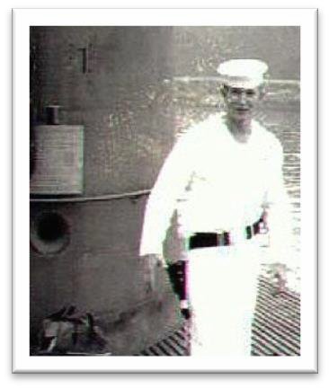
to splash the water and attempted to crawl up onto the portion of the sub’s stern called the “turtleback.” The few Ronquil sailors who were working topside scrambled to the stern, including the topside watch, who ran from his position near the gangway to respond to the intrusion by Sawyer and Jenkins. This diversion would allow Miller to get aboard the Ronquil long enough to see how the Panther was mounted. As the commotion began, Miller, who was standing close by behind a parked car, ran across the sub’s brow and entered the sail’s side door.
Tunny crewmember Floyd Kuhl from Hutto, Texas, stands Topside Watch in Yokosuka, Japan.

As Sawyer and Jenkins splashed astern of the Ronquil, one crewmember came out of the after torpedo room hatch and began yelling, “Panther stealers, Panther stealers!” Miller, who had slipped onto the Ronquil and made his way to the area inside the sub’s sail, encountered a Ronquil crewmember who was coming out of the conning tower hatch. He confronted Miller, saying, “Hey! You aren’t part of this crew!” About that time, a couple of others who were also responding grabbed Miller and restrained him. They took Miller below to the crew’s mess where they interrogated him. After several minutes, they shaved his head then let him go, warning him not to return to the Ronquil. Miller returned to the Tunny, where he shared his observation that the panther was mounted with four-inch long one-half-inch thick bolts that were welded over. Miller would return to the Ronquil.

First Attempt - A Bust!

Now we knew how the Panther was mounted and what was needed to remove it. The conspirators made an attempt to take it on the afternoon of Thursday, 16 April. The plan was to remove the Panther while the Ronquil crew was below deck during their lunch hour. Several dozen Tunny sailors had made their way across the submarine base to Pier S-11 where Ronquil was moored. The expedition members hid themselves behind a large pile of wooden pallets that were stacked high across the parking lot adjacent to North Waterfront Street. They waited quietly and patiently, trying not to look too obvious and stay hidden as well as they could. They waited to make their move at the right time. The plan was to get aboard the Ronquil and secure the hatches with the crew below during their lunch hour, and simply remove the panther. Unfortunately, an astute and watchful Ronquil crewmember spotted them and began yelling "Panther Stealers!"
Ronquil’s topside watch grabbed the sub’s 1MC and announced over the sub’s PA system, “Panther Stealers, Panther Stealers.” Ronquil crewmembers began to pour out of the boat, wielding baseball bats and large wrenches. According to a former Tunny crewmember, retired Captain John H. Maclaren, “repel boarders” took a very serious tone on the Ronquil. “Mac” said a permanently mounted rack of baseball bats and large crescent wrenches was at the base of each ladder leading up and down the submarine’s hatches. He further stated that the Ronquil’s crew was exercised at that drill more than they were any situation defined in the Operational Readiness Inspection (ORI) book. As part of that drill, when the topside watch announced “Panther, Panther”, the crew would erupt out of each hatch, flailing about with bats and
wrenches. To avoid capture from Ronquil’s crew, all of us who had gathered behind the pallets quickly dispersed around the base. Fortunately, none were caught.

Second Attempt - Another Bust!

Another planning session took place while consuming a few beers that same afternoon at Beeman Center. We thought we could try to get aboard the Ronquil and secure the crew below during the evening hours while a movie was showing either in the Forward Torpedo Room or the crew’s mess. That evening a smaller number of us again assembled at Pier S-11. Again, we hid behind the stacked pallets. When we arrived, however, there was a movie all right, but it was being shown topside in front of the sub’s sail area.
Do not underestimate a submarine sailor’s ingenuity and creativity. Another plan was crafted. The plan this time was to capture the Ronquil’s topside watch and secure the Ronquil’s crew inside their submarine in the early-morning hours. This would be our last chance as Ronquil was scheduled to leave Pearl the next day, Friday, April 17.

Success!

What happened Friday morning was pure genius. They say three times is a charm, and in this case it was! Our small band gathered near where the Tunny was moored at Pier S-1A at 0430 in the morning. A Navy van and a driver from Guided Missile Unit #90 were waiting for us. We used the vehicle to make it look official and not appear to be too suspicious to the Ronquil’s topside watchstander, who would more likely be alone at that time of the morning. Inside the Suburban would be a small band of Tunny crewmembers.
The evening before, I’d typed up a set of phony transfer orders and a phony package of personnel records for a transfer of a crewmember, Richard E. Copeland (Independence, Iowa), CS3(SS), USN. The orders said he was being transferred from the Tunny to the Ronquil as a new cook to make the rest of their deployment to WESTPAC. In addition to Copeland, there were ten of us in that van. Their names and assignments:
  - Van Driver, name unknown, possibly from GMU #90
  - Guided Missileman Garth Fred Miller, Topside Watch Detainer
  - Commissaryman Richard Eugene Copeland – New Cook supposedly reporting to Ronquil
  - Electronics Technician Thomas Samuel Samuelson (Brooklyn, New York), Forward Torpedo Room Hatch Sitter
  - Engineman Elo Henry Foyt, Jr. (Fort Bend, Texas) – Panther Statue Remover and Runner
  - Engineman Keith “Buzz” Sawyer (Sacramento, California) – Panther Statue Chiseler #1
  - Electrician’s Mate Edward Casper Karamol (Springfield, Ohio) – Panther Statue Chiseler #2
  - Yeoman Raymond Vance Olszewski (Birdville/Natrona Heights, Pennsylvania) – Conning Tower Hatch Sitter #1
  - Electronics Technician Charles Joseph Bonner (Lackawanna, New York) (Lackawanna, New York) – Conning Tower Hatch Sitter #2
  - Radioman Donald Carl Parod (Chicago, Illinois) – After Battery Hatch Sitter
  - Radioman Charles M. Smith - After Engine Room Hatch Sitter

  - Guided Missileman John Joseph Jenkins, Jr. (San Diego, California) – After Torpedo Room Hatch Sitter.
The identity of the van’s driver from the Guided Missile Unit NINETY is unknown, but one Tunny crewmember, Fred Miller, recalls the driver was from West Virginia and in his youth ran moonshine before he joined the Navy.

At about 0450, we all piled into the back of the van with the unidentified driver. Copeland was riding in the shotgun seat with Miller in the middle. After a short drive across the base, the van pulled up beside Ronquil’s gangway. Standing in his position as the Topside Watch was a lone Ronquil sailor. The time was 0500 and it was very quiet there at the pier and on the Ronquil.
Copeland, the new cook, opened the door and jumped out, yelling to the Ronquil’s Topside Watch, "Is this the Ronquil?" The topside watch seemed to think this appeared to be an official event, and yelled back "Yes, it is! Why?" Copeland, who was in a dress white uniform, replied, "Well, looks like you have a new cook reporting.” Copeland then asked the watch to give him a hand with his seabag, adding that it was pretty heavy. “Sure, why not?" The topside watch thought for a few seconds and crossed the gangway to the pier.
As the two walked toward the back of the van, Copeland grabbed the topside watch and placed his hand over his mouth to prevent him from alerting any of the Ronquil's crew who may have come topside from below in the submarine. At that same moment, Miller climbed out of the front seat, the back doors of the van sprang open and out came the rest of us. With some help from Miller, the watch was held down while the rest of us quickly scampered aboard the sub, heading to our assigned positions. With no Ronquil sailors topside, all the sub’s hatches were secured in quick sequence. The entire Ronquil crew were sealed below in their own submarine and could not get out.
When Bonner and I reached the conning tower hatch, we found that a phone line and a thick ship-to-shore power cable ran down through the opening to the sub’s conning tower below. This became a challenge to our ability to keep the hatch shut so the forces below could not get out. By this time, the small-framed Ed Karamol squirreled himself up underneath the sail’s superstructure to where the bolts held the Panther in place. Foyt recalls that he hammered the chisel while Buzz Sawyer held the chisel. BAM! In quick succession, there was another BAM! Then another! Then BAM! BAM! The precision hits quickly broke through each of the welds enough to break off the bolts, freeing the Panther from its mount.
While the removal was going on, an unknown number of Ronquil sailors had gathered in the conning tower as Bonner and I held the hatch to it down as well as we could. As we sat on the hatch, we could hear verbal threats, along with butcher knives being shoved up through the two to three-inch opening. “You sons of bitches, you are going to get yours! We are going to kill you!” Bonner and I looked at each other in the darkness with only the light shining up from the hatch below. After what seemed like an eternity, Foyt yelled out “I got it!” With that, he grabbed the Panther from its mount and exited the sail through the small door, jumping onto the deck a few feet below, running across the brow like a football player heading for a touchdown. By that time, Karamol and Sawyer were close behind.

Bonner and I continued to hold the hatch down as long as needed for the three chiselers to escape with the Panther. Then Bonner said to me, “Go ahead, Ski, take off!” With that, I left Bonner behind and jumped to the deck below, running like the wind. I crossed over the gangway, onto to the pier, and headed for the barracks. We all knew we’d be dead if we were caught.
Samuelson had already let loose of the forward torpedo room’s hatch and had headed for safety as well. Not far behind him was Don Parod and Charlie Smith. Then JJ, who was on the after torpedo room hatch, sprinted to the gangway. He had brought with him a piece of thick rope, which he tied around the hatch's wheel. When he heard “We got it!” JJ said he “ran like hell” forward from the Ronquil’s stern and made it across the gangway.
As I ran, I didn’t look back. I could hear unintelligible shouts and banging of tools against the Ronquil’s superstructure. The Tunny’s acquisition team members scattered throughout the base. Some ended up going into the Tunny's assigned section of the base barracks, some went back to the Tunny itself. I ended up at the barracks where I had to catch my breath from the 500-yard Olympic run I’d made from Pier S-11. I thought I would be safe among the unwary Tunny crew, some of whom were just waking up. Those of our small band who had gone to the Tunny began breaking out wrenches and anything else we could find to defend the boat from any possible retaliatory attacks from the Ronquil’s crew. It was now sometime between 0530 and 0600. Tunny’s Duty Officer, Lieutenant “Ted” Hussey, was awakened by the noise and got up to find out what was going on.
Some number of the Ronquil sailors who came after us went to the barracks. Don Freeman, a former Tunny crewmember and now a Ronquil shipmate, knew exactly where the Tunny’s section was located. Several Tunny sailors who had been sleeping were awoken by the commotion as the Ronquil sailors began harassing the sleepers in search of their Panther. Regretfully for a couple of Ronquil sailors, they grabbed World War II veteran EM1(SS) Kelly Elkins, who was in a deep sleep following the previous evening’s drinking spree. Kelly came off his lower bunk and blindly started throwing punches.
By 0600, those of us who were involved had regrouped back at the Tunny. There we began reviewing what had happened and tried to account for all who were involved. Bonner was missing! He’d been on the conning tower hatch with me! Meanwhile, our former shipmate Don Freeman left the barracks leading several Ronquil crewmembers to where the Tunny was moored. Someone from the Ronquil must have caught up with them and redirected their efforts to another target, which turned out to be Tunny’s Captain Blair.
Captain Blair recalled the phone call he received at about 0530 that morning. A voice Blair did not recognize identified himself as the duty officer on the Carbonero and said, “Your duty officer is too busy to call and asked me to do it for him. He said to tell you that your maneuvering room was flooding, your ship is in danger of sinking, and that you should come down to your ship right away.” Blair immediately hung up the phone, donned his khaki uniform, jumped into his yellow Chevrolet convertible and headed to the Submarine Base and to his submarine.
On the way to the base, Blair did a mental review of the situation in anticipation of what was ahead. He recalled that the night before he had given his chief engineer and duty officer, “Ted” Hussey, permission to replace the packing in the stern tube glands on both propeller shafts. He recalled further that it would be a tricky job and pressurizing the stern room would be necessary
to accomplish the task. Was that the cause of his boat’s sinking? His rationalization seemed to make sense, at least until he got to the Tunny.
Blair told me afterwards, “I didn’t even slow down for the Marine guards at the Sub Base gate! I’m probably lucky that they didn’t shoot me in the back as I roared through.” He went on to describe the portion of his trip after passing through Makalapa Gate. “When I swung around back of the officer’s club (Lockwood Hall - on Pierce Street), there was a gang of men racing in my direction; I figured they were base personnel racing to help the Tunny. I had no idea they were out to capture me and take me to WESTPAC with them. Leading the gang, Blair said, was QM3 Freeman from Tunny who’d just happened to have transferred to Ronquil for their trip to WESTPAC. “I did not realize that he had been transferred; which was the reason I wasn’t alarmed when I saw the gang – I recognized their leader as a Tunny sailor!”
When Blair finally arrived at the Tunny, Ted Hussey was on deck, waving frantically to tell Blair that it was all a joke. “Some joke!” Blair told me years later, adding, “When I found out the maneuvering room wasn’t flooding, I went below and collapsed on my bunk to try to get my breath. I almost had apoplexy I was so frightened and enraged!”
To add to all this ruckus, the Sub Base was holding a Civil Defense Drill during the early- morning hours; this was an exercise for the base police to make sure whoever is on the base is authorized to be there. Anyone who did not have proper identification with them would be detained for questioning at the Sub Base Security Office. Sometime between 0600 and 0800 while this Civil Defense drill took place, several Ronquil sailors were stopped, questioned, arrested by the base police and taken to the brig for detention. Apparently, they were running around the base without their identification cards on them and parts of their uniforms were absent as they were wearing just T-shirts and dungaree pants. One of our own crewmembers (I believe it was Electronics Technician Robert "Bob" Marcotte) was apprehended, as he did not have his identification with him going to the boat from the barracks. He was put into the brig with them. There he was, a lone Tunny crewmember in the brig with a bunch of Ronquil sailors, listening to them jabber about their Panther being stolen by Tunny crew. Of course, he did not offer to tell them he was a member of the Tunny’s crew; if I remember correctly, he told them his boat was the Carbonero.
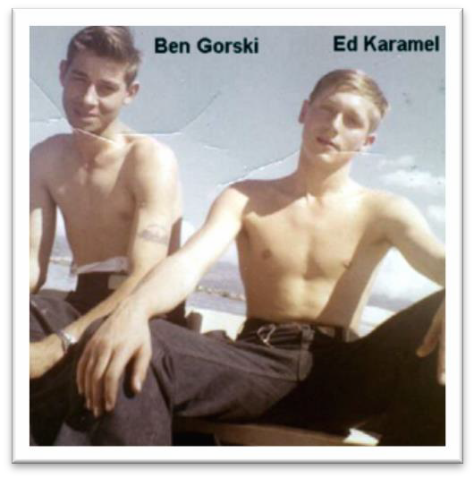
Now that the kidnapping attempt of Blair by the Ronquil crew had failed, Ronquil crew turned their attention to a little boat of ours which Freeman also knew about. The boat was called “Tunny Junior,” an eight-foot- long dinghy that the crew used to inspect the hull of Tunny. When available, it would be used by crewmembers such as Ed Karamol and Ben Gorski for scuba diving or fishing. I recall that one time the Tunny anchored near the Port of Lahaina, Maui, and Tunny Junior carried a number of us ashore for some R&R. Tunny Junior was usually stored in the Regulus hanger if no Regulus missiles were inside. This day, however, Tunny Junior was lying on the pier. The only reason that Ronquil wanted to steal it was to use it as a bargaining chip to get their Panther back from us.

The Aftermath

At about 1000 hours, the Tunny topside watch announced over the 1MC “Ronquil, Ronquil” and we poured out of the sub to see a bunch of Ronquil sailors trying to steal Tunny Junior. Before any of us could get to the Ronquil sailors, they were gone like the wind. Blair recalled that Ronquil had succeeded in putting Tunny Junior on a flatbed truck and hauled it away. Blair credits the Sub Base guards who saw the truck, stopped it, and put the men on report for using the wrong kind of transportation for hauling the boat! Where did Ronquil get that truck? That’s what I want to know!
By this time, our missing shipmate, Charles Bonner, who had sat with me on the conning tower hatch, was in captivity on the Ronquil. Years later, Bonner reminisced with me about the ordeal. While he was trying to leave Ronquil, he had stubbed his toe and couldn’t run. The Ronquil crew captured him and held him topside where they proceeded to shave his head and his hairy body, and then painted his back and chest with red lead paint and wrote the words “Panther Stealer” across his body in black paint. Then they poured the paint down his pants. He recalled that the Ronquil had kept him for three to four hours, but he did not remember how he got back to the Tunny. When he did return, however, he remembered standing on the dock near where Tunny was moored and with the help of some of his shipmates, the paint from his body was removed with turpentine while Captain Blair watched.
Captain Blair said he called Chief Mathes to his quarters and asked him what he knew about what had happened. That was when Mathes told the Captain that he had made the bet with Ronquil’s COB. Blair said he verbally reprimanded the COB and told him to find the Panther and bring it to him “on the double.” Some of us spent time looking for it on the boat, not knowing that Elo Foyt had stashed it in a locker in the barracks before the mayhem started. The Panther was soon found and handed over to Captain Blair.
Captain Blair made a phone call to a friend of his who worked at the Pearl Harbor Naval Shipyard and asked his friend, Tom Takahachi, not to ask any questions and told him he “needed a favor.” Blair said he told Tom that he would be sending someone over to the shipyard with the Panther figure and would give him instructions as to what he wanted done with it.
While the trip to the shipyard was being made by Frank Lewis (Fulton Hemps, Arkansas), QM1(SS), the Ronquil’s CO and XO, COB and an entourage of its crew had crossed the submarine base over to the pier where the Tunny was anchored. The topside watch announced over the 1MC that they were on Tunny’s deck waiting to see Captain Blair with a horde of Ronquil crewmembers standing on the pier.
On the deck of the Tunny, Captain Blair and Lieutenant Commander Doug Stahl (the XO) squared off with the CO Franz and XO Whitmire) of the Ronquil. I remember overhearing various argumentative exchanges of words about getting their Panther back. At one point, I heard Captain Blair say in an enraged voice, "How would you like it if you were called at 0530 in the morning and telling you that your maneuvering room was flooding?" "Hell, I couldn’t get out of my submarine at 0530 this morning," replied the CO of the Ronquil. With that, Franz turned and stormed off the Tunny, yelling back to Captain Blair, "I want that Panther and I want it before I set sail this afternoon. And it better be unharmed."

About an hour or so after that exchange of unpleasantries, the Panther was returned to the Tunny from the shipyard and taken directly to Captain Blair in his quarters. Blair called the COB into his quarters, where Blair ordered him to take some of the crew and deliver it to the Ronquil. Those of us who were involved in the removal of the Panther were part of the procession. Crowded around the COB, we read the words which were engraved on each side of the Panther: “U.S.S. TUNNY (SSG-282)” and below those words was the date of “4-17-59.” Then across the Panther’s smooth black ‘butt’ the words, "CASTRATED IN HAWAII” were engraved. The engraving work that Takahachi did was excellent and deep. The coup de grâce was what was done to the Panther’s reproductive system. To back up the word “castrated,” well, you guessed it, the Panther’s gender was changed from a male to a female with a little red touch of paint replacing the area where the Panther's gonads had been located. It was history in the making that many still remember today.
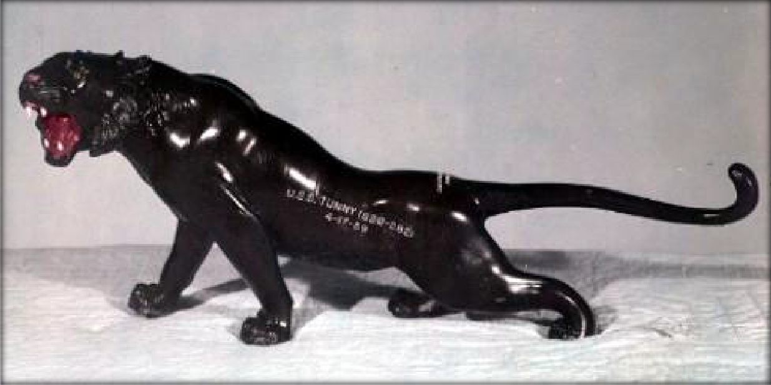

In my original article, I wrote that the Ronquil was glad to get their Panther back. NOT! According to Captain Blair, they were not happy at all! He added in his recollections that they refused to take it from our delegation. One of the Tunny crewmembers removed the Panther from the oriental silk pillow on which it was presented, and gingerly placed the statue on Ronquil’s gangway, turned and re-joined the group, who then departed from the area leaving the mutilated Panther for the Ronquil crew to do with it what they pleased.
During my research on the individuals who were involved, I found an entry dated 18 April 1959 in Ronquil’s personnel diary reflecting that Chief Andrew Loftis was transferred from the Ronquil to Commander Submarine Squadron SEVEN (COMSUBRON 7). “Abs on TAD undtreat” which translates to “absent on Temporary Additional Duty under treatment.” The date of April 18 is also notable because Loftis was transferred to the Squadron on Saturday, 18 April 1959 and the entry below it reflected “SAILING – Submitted on Sailing and [Ronquil] will be underway over the end of the month.” This meant that the Ronquil did not leave Pearl as planned on April 17, but left the next day. It also meant that Chief Loftis did not go with them. In early

June 1959, Chief Loftis returned to duty on Ronquil from COMSUBRON 7 and a month later in July 1959, Loftis submitted his request for transfer to the Fleet Reserve. In November 1959, the World War II veteran was permanently transferred to the U.S. Naval Hospital in San Diego for temporary duty under treatment. I can only assume that he retired shortly thereafter after serving 20 years in the Navy. In this author's opinion, Chief Andrew Loftis was the only known Ronquil casualty from this event.
Additional communications with Tom Johnson, a 20-year-old boat yeoman on board Ronquil at the time gave me more information. Tom shared his recall of the incident in an email to the author. “Tunny crewmembers captured the topside watch, and secured all hatches leading off the ship.” He added, “Most of the crew, including the CO and XO, were on board since we were in transit to WESTPAC. After at least 30 minutes, the hatches were opened and things went back to normal. We got the Panther back the next day but with the absence of his testicles.” Johnson said that he believed Tunny got into trouble with COMSUBPAC, who was RADM Grenfell, because of the unsafe actions of securing the hatches. Johnson also observed, “It was a good thing they (Tunny) locked the hatches at the outset, as Ronquil’s XO at the time (Donald Boone "Big Daddy" Whitmire) stood 6 feet 2 inches, and weighed nearly 300
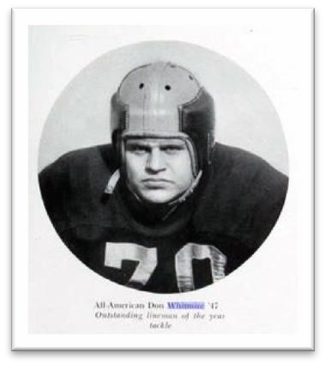
lbs.” Don Whitmire (shown here) was a three-time All-American tackle at Navy, and a member of the college football hall of fame. He later made RADM. Johnson said that “he would have roughed up the perpetrators if he’d caught them.” Johnson, who retired from the Navy as a Commander in 1980, also confirmed that the Ronquil’s COB was FTC Loftis.
We on Tunny thought the whole event was most gratifying and memorable. Everyone who was involved was proud of the accomplishment. It made the bond between the crewmembers that much stronger and made us all even more proud of the Tunny name. I, for one, was more pleased by our Captain, Marvin Smith
Blair, and how he handled the whole ordeal. No one on the Tunny got in trouble for it, but we had two casualties, Bonner and Miller. The impetus for my writing this book has always been this most memorable event which I was proud to have been part of. I hope I have captured it accurately and honor those of you involved in it for giving the Tunny its first and only mascot. If such an incident were to happen in today’s “politically correct” Navy, however, heads among other things would surely roll. But this is NOT the end of the story…
Before he left the Tunny a few months later in July 1959, Lieutenant Commander Blair received orders to report to the Navy’s Nuclear Power School, in New London, Connecticut. During his change of command ceremony at Pier S-1A when he was relieved by Lieutenant Commander Morris Anthony Christensen, USN, on 1 July 1959, Blair did something very special. At that ceremony, Captain Blair presented to the Tunny's crew a replica of the Panther that was stolen from the Ronquil sans the engraving. This statue then became Tunny’s mascot, a permanent fixture on Tunny’s sail, further symbolizing the unity of future Tunny crews.
It was mounted on the Tunny's sail, the upper most fixture of the submarine's superstructure. Shown in the photograph is the Panther mounted on the Sail during a deterrent patrol to the North Pacific. These photos were taken by the author within an hour of each other.

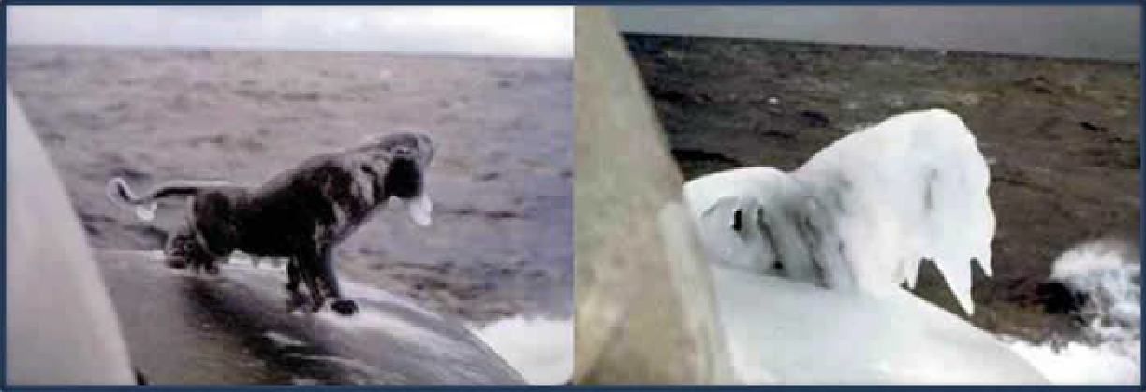

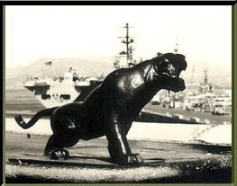
Tunny's Panther mascot is again shown, but in 1968, when it was still mounted on Tunny's sail. The photograph was taken by former crewmember Fireman David Louis Buehn, Los Angeles, California. At the time, the Tunny was under the command of Lieutenant Commander William Carbine Green, San Diego, California, when it was operating as a troop carrier in the Western Pacific.

Recollections of the Incident

Marvin Blair wrote, after he read my story. “Pretty
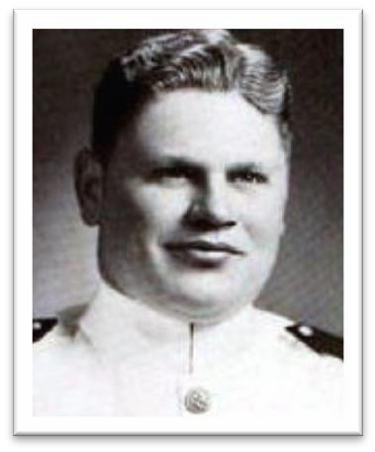
close, but some facts are missing. When the Ronquil guys tried to capture me, Yeo didn’t mention that they intended to tie me up and stuff me in their no-longer-used 5” ammo storage room under the crew's mess and take me to Japan with them, only telling the skipper when they had crossed the International Date Line. If that had happened, there would have been enough courts martial to go around for both subs. Also, I was the one who
called the COB to the wardroom and gave him holy hell for what had happened, and ordered him to bring the panther to me. When I got it, it was I who called Tom Takahachi in the shipyard instrument shop, asked for a personal favor and told him what to engrave on the panther.”
John “Mac” Maclaren recalls the incident and wrote, “Oh Yeah! That was a fun time all right. The XO of Ronquil was Don “Big Daddy” Whitmire – the only man to have earned All-American honors at both Alabama and the Naval Academy. He was to say the least, a BIG man. Some folks were known to holler “Green Board” when he came down the upper CT (conning tower) hatch.” “Mac” added that he believed it was QM1 Frank Lewis who took the
panther to the PHNSY (Pearl Harbor Naval Ship Yard) chrome shop. “I think Marv went through inhalers while several of us were trying to ‘splain’ (sic) what had happened (most of which we made up as we went – basically, we had no idea, or so we said!). The Ronquil crew was none too

pleased, to say the least. How the Submarine Force has changed – we all would have been court- martialed for our antics. As it was there
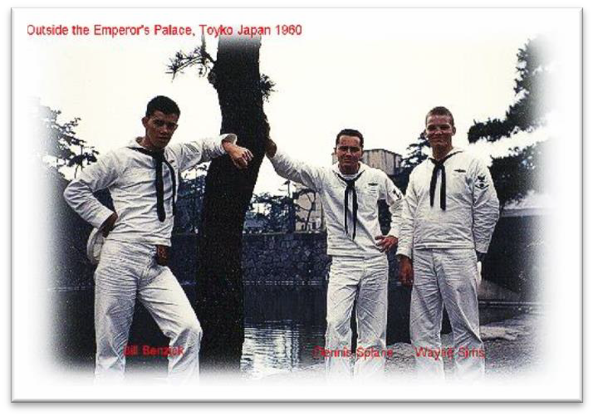
were no repercussions that I am aware of.”
William Joseph Benzick wrote in 2007 that he was new on board probably by a week or ten days and did not know what the hell all the excitement was about that day when Bonner showed up half-painted and half-shaved. A new crewmember was often not included in these events and might not even know where the forward torpedo room was located at this stage of his submarine experience. “So I was looked on as a new guy and did not understand until months or years later what
a big deal this was. Great story and true to every point written.”

Bill Benzick came aboard Tunny as a Seaman Apprentice and later became a Commissaryman, and he was a great one, too! That is Benzick on the left in the photo with Dennis Splane (Center) and Wayne Sims (Right).

Burton Haviland (Seattle, Washington), a former Electronics Technician who served on Tunny in 1958, recalled in 2009 that “someone prepared orders for a new arrival aboard the Ronquil. I think I carried the clipboard, followed by the new arrival. While the deck watch was distracted with the arrival activities, at least two guys from the Tunny followed up the gang plank, posing as returning crewmembers and grabbed the deck watch. Then followed men who secured the hatches and men to remove the panther. When the panther was safely ashore with the removal crew, the hatches were released, the deck watch was released, and we all returned to the Tunny in jubilation. If other memories differ you’ll just have to take your best guess as to the facts.”
Sorry, Burt I do not recall your involvement in the actual removal that morning. But, as you say, perhaps you were involved but maybe it was in one of the the earlier attempts.

In 2011, at a fellow submariner veteran’s dinner, Dan Moss shared the Panther story. One veteran who served on the Ronquil recalled it had a panther that was about 30-36 inches in length, which was kept in the Forward Torpedo Room (FTR). He said that Tunny did steal it and had a sombrero welded to the head of the Panther. The Ronquil veteran shared further, “…some of Ronquil’s crew swam over to Tunny and attached a 20# canister containing a yellow dye marker to the Tunny’s superstructure with a hole punched in the can.” The next day, the former Ronquil veteran went on, “…Tunny went to sea and operated with aircraft ASW forces.” Of course, being submerged, the yellow dye marker left a continuous yellow trail which the aircraft followed and pounded the Tunny with Practice Depth Charges (PDCs). Moss added that the veteran appeared adamant about his version being the real story, impressing the ladies who were at the table how someone could remember so much after so many years. This version, in the author's opinion, is one heck of a sea story, told only to impress the ladies.

I had a discussion with "Benny" Williams, a former Quartermaster on the Ronquil, at a submarine vets regional meeting in Laughlin, Nevada in 2012. Williams, who was onboard the Ronquil when the incident took place in 1959 said that it was his idea to call the CO of the Tunny, Captain Blair, that morning telling him that his Maneuvering Room was on fire. Williams said that it was the XO, Don Whitmire, who supposedly made the call to Captain Blair.

Where is the Tunny Tiger, the "Blair" Panther?

Former Commanding Officer Marvin Smith Blair bestowed a near-duplicate male Panther statue upon the Tunny crew when he departed in July 1959. That statue became Tunny's mascot and was mounted to the Tunny’s sail on the bridge and with bolts that were welded over to keep it in place. The statue remained there and was there when Tunny was decommissioned on 28 June 1969. The question is: where is that statue today? Did it too go to Davey Jones' Locker with the Tunny? Or, did it end up in a former crewmember's hands and has not surfaced since? The photos below show the Tunny’s iconic Panther statue at various dates mounted on the Tunny's bridge.
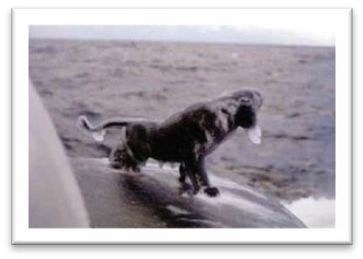
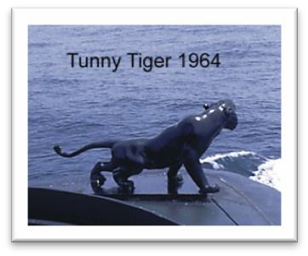
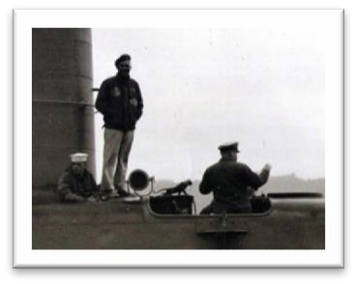

Tunny's Panther Statue on Tunny. Photo taken by author on Northern Run 1959 | Tunny Digital Archives Photo | Tunny leaving Yokosuka, Japan, January 1968. Courtesy of "Bill" Green  (standing)
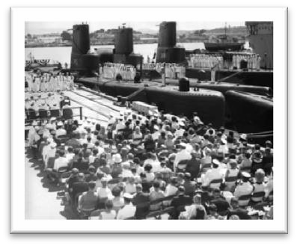
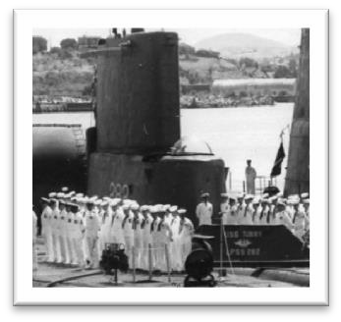
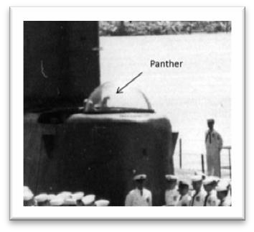

Decommissioning Ceremony 28 June 1969  at Mare Island Naval Shipyard | Blow up #1 Shows Tunny's Sail  and crew 28 June 1969 | Blow up #2 Panther is Still Mounted 28  June 1969

The evidence above indicates that the very last and known sighting of the Tunny’s Panther statue was believed to have been on 28 June 1969 at Tunny's decommissioning ceremonies held at Mare Island Naval Shipyard. One photograph found at www.navsource.org that was taken that day shows the Bream (AGSS 243), Tunny (LPSS 282), and Charr (AGSS 328), and hundreds of attendees.

However, in July 2009, I learned that Tunny's Tiger/Panther was located at the Seattle Yachit Club in Seattle, Washington. In response to my seeking further information, I received an email from Captain Terrence “Terry” Michael Mahony (Salem, Oregon), USN (Retired) who had served on Tunny as a Lieutenant between 1965 and 1966 when it was an SS for the second time. Mahony was responding to an earlier inquiry on a lead I had received about it being at the Yacht Club and explained under the subject line of “Fate of the Tunny Tiger,” the email explained how the "Tunny's Panther" got to the Seattle Yacht Club. Mahony wrote:
“During our shipyard conversion in Bremerton to a Troop Carrier, the Tiger disappeared. We were certain that a shipyard worker had made off with it. Turns out a crewmember was the villain and returned it with great chagrin. The XO wanted to take him to Captain's Mast but Bob Melim (CO of Tunny at the time) said no. After Tunny’s Vietnam tour, I [Mahony] was on SubPac staff, and we decided to use her in some torpedo tests. She didn’t give up easily – took 3 torpedoes to put her away. A friend of mine was assigned to do the “strip ship” before the Sinkex. He knew about my love for Tunny and one morning I came to work and there on my desk was the Tunny Tiger. Some friends mounted the Tiger on a piece of Hawaiian Koa wood. I took the Tiger home, and there he rested (as a door stop) for about 25 years. In the meantime, we (Mahony and his wife, Beverly) moved to Seattle and I eventually retired. I was put on the Seattle Navy League and Seattle Yacht Club committee to select the “distinguished civilian award,” honoring that person who contributed the most to sea service support in the Seattle area. The question came up on what to present; I had the perfect award
– the Tunny Tiger. Each year it is engraved and presented at the Annual Navy League Award dinner and then returned to the Yacht Club where it rests proudly in Club’s trophy case. So, if any ex-Tunny (SS-282) sailor visits Seattle and would like to see the Tiger call me and he will get a free lunch with a viewing.”
This is not the end of the story. Following up on Mahony’s claim that the Tunny’s Panther was being used as a performance recognition trophy by the Seattle Yacht Club, I contacted the Seattle Yacht Club's manager and obtained photographs of the panther/tiger of the “award” that Mahony described in his email.
Then, in 2015, former Tunny Quartermaster Dan Moss and his new bride, Layne Rumbaugh Moss, were visiting the Seattle area and took the time to make a special trip to the Yacht Club. While there, Dan also took photographs of the award.

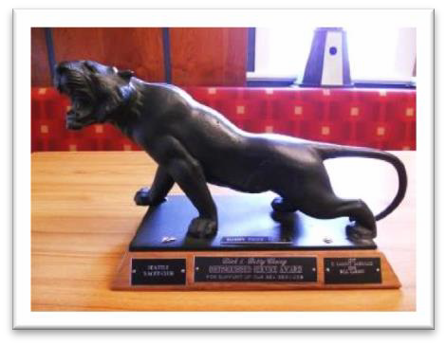
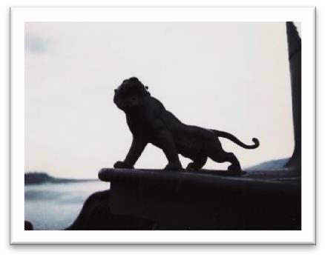
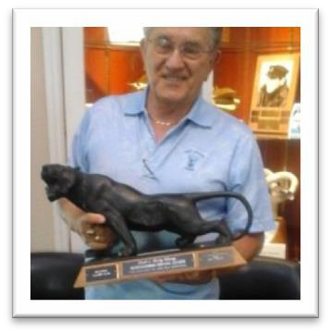

Seattle Yacht Club Distinguished Civilian Award Tiger | Another Tunny Tiger statue photo taken 1966 | Boat QM Dan Moss

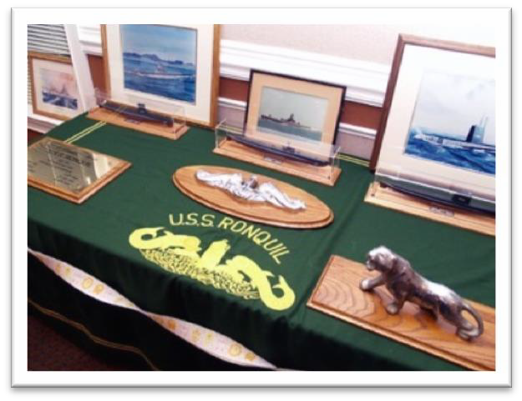
Electronics Technician Richard Michael “Ozzie” Osentoski, Detroit, Michigan, who served on Ronquil from 1962 to 1966 has a Tiger/Panther statue that is displayed at their boat's table during reunions and conventions (see above lower left photo). Note the distinctive differences in the tail on the Ronquil's statue. “Ozzie” said that when he drives to Ronquil reunions from his home in Harbor Beach, Michigan, he transports the nearly 35-pound statue to put on display. The "very curvy" tail of Ronquil’s statue distinguishes it from the “near straight-out tail” of Tunny's Tiger.
One additional story from an unknown source was that the Commanding Officer of the Ronquil had thrown their sub’s statue over the side while Ronquil was in Yokosuka because the Ronquil had become the target of many other submarine crew attempts to remove it after they heard of Tunny's success! The identity of the CO of Ronquil is not known. Although not confirmed, that statue might have been the same that Tunny stole, engraved, and castrated.
Another story was that someone who was familiar with the incident visited Ronquil, said that they inspected the Ronquil’s violated Panther statue, and could feel Tunny's engraving and castration damage to the statue even though attempts were made to paint over them. This, obviously, had to be before it was thrown over the side.
The whereabouts or what happened to the "Blair" Panther, which later became known the "Tunny Tiger" after Tunny was decommissioned remains a mystery.

Ronquil Panther Acquisition Team (RPAT) – The Bandits

The following individuals were responsible for establishing Tunny’s first and only known mascot. The mascot represented quite a bit more than a mere effigy of a panther that became known as the Tunny Tiger and the crew became known as the Tunny Tigers. The names of those eleven Tunny crewmembers who achieved the successful removal of the Ronquil’s Panther from its seat on the sail of the submarine are listed below in alphabetical order.
Charles J. Bonner performed the task of sitting on the Conning Tower hatch along with Olszewski to keep the Ronquil’s crew below. That hatch was the only hatch that could not be completely shut during the raid as electrical ship-to-shore cables ran through it. Bonner and Olszewski had to sit on the hatch to keep the crew below while the Chiselers removed the Panther from its mount on Ronquil’s sail. Charles Bonner is the hero who was unfortunately captured, handcuffed, shaved, and his body painted by the Ronquil crew. Charles J. Bonner was born 2 September 1937 in Lackawanna, New York, to Bernard and Mary Bonner. Bernard worked as a local steel mill open-hearth operator while the couple raised their only child, Charles. Charlie lives in Grand Island, New York.

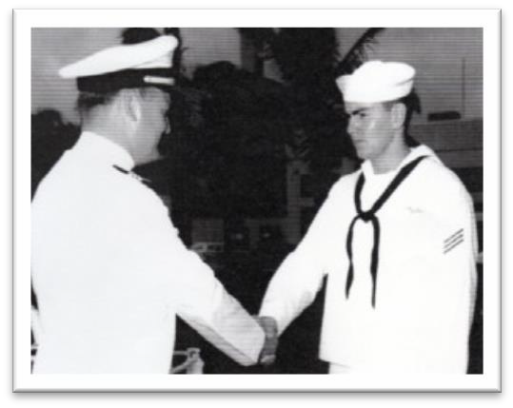
Richard Eugene Copeland played the role as the “new cook” reporting to the Ronquil to get the sub’s Topside Watch to come off the sub so that he could be detained and kept from alerting the Ronquil’s crew below. Richard Eugene Copeland was born 1 October 1937 in Independence, Iowa, to Emerson and Ruth (née Gehere) Copeland who raised their large family of six children (four sons and two daughters) while Emerson made a living as a truck driver. Richard Eugene graduated from Independence High School in 1955 and shortly afterwards he enlisted in the Navy, volunteering for submarine duty. After completion of submarine school in New London, Connecticut, Copeland reported to the Tunny as a
Seaman Apprentice on 30 April 1956 while the Tunny was operating out of Port Hueneme, California. While serving on Tunny, Copeland became a “cook striker,” received his dolphins for qualifying in submarines, and made Tunny’s first Regulus Patrol in 1958. He was assigned to the Gudgeon (SS 567) temporarily, then returned to Tunny. He was promoted to Commissaryman Third Class and on 1 September 1959 was transferred off Tunny to be separated from the Navy. He returned to Iowa, where he settled in Marion. Dick Copeland and his wife, Barbara “Bunny” (née
Williams), owned and operated an antique store called “The House of Nostalgia.” Richard Eugene Copeland is shown in the photograph receiving his dolphins from Tunny’s Commanding Officer, Marvin Smith Blair. He departed on Eternal Patrol on 14 December 2005 while residing in Independence, Iowa. Dick shared a copy of a “Page 13” from his service record awarded to him for a previous successful mascot-stealing incident. The commendation citation which follows was signed by Walter Dedrick, LCDR, USN, Tunny’s Commanding Officer at the time.

“You, Richard E. COPELAND, SN, USN, are commended for your clumsy though successful actions on 7 February 1957; for on that fateful day during the hours of darkness, you carried out a plan so bold and diabolic, to wit: stealing the bronze Buddha from the
U.S.S. REMORA; that it will probably go down as one of the most inflammatory acts in the history of the submarine nest in San Diego, California. You also succeeded in making San Diego unsafe for TUNNY or her stout men for several years to come.
Though commended for your planning, ingenuity, and bravery, you are hereby censored most severely for being so chicken-hearted as to give, or to let your shipmates give, the Buddha back to REMORA. For this dastardly act, you must be punished!
You are hereby sentenced to be restricted to the limits of this ship for a period of three (3) full weeks, commencing at 0800, 25 February 1957.”

Elo Henry Foyt, Jr.’s responsibility during the successful Ronquil Panther Raid was to remove the Panther from its bolted and welded-over mount on the Ronquil’s sail, along with Keith “Buzz” Sawyer, and Edward “Ed” Karamol. Elo Henry Foyt, Jr. was born on 11 August 1938 in Fort Bend, Texas, to Elo Henry, Sr., and Anna Mary (née Venglar) Foyt. Elo, Sr. earned a living as a truck driver for a wholesale feed mill in the local area while he and Anna raised two sons. Elo, Jr., the younger of the two sons, joined the Navy in 1956 after graduating from El Campo High School. Foyt volunteered for submarine service and attended the Enlisted Basic Submarine School, New London, Connecticut. On 24 February 1958, Engineman Fireman Foyt

reported aboard the Tunny while it was in port at the Submarine Base, Pearl Harbor, Territory of Hawaii. A few months later, the Tunny participated in a SEATO Exercise in the South China Sea, visited several Far East ports of call, and returned to Pearl, only to be sent to sea again as the first Regulus Deterrent Missile patrol. While
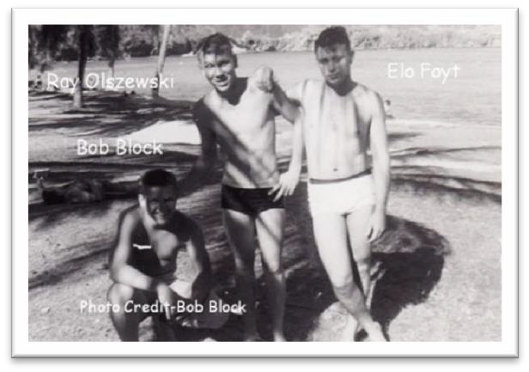
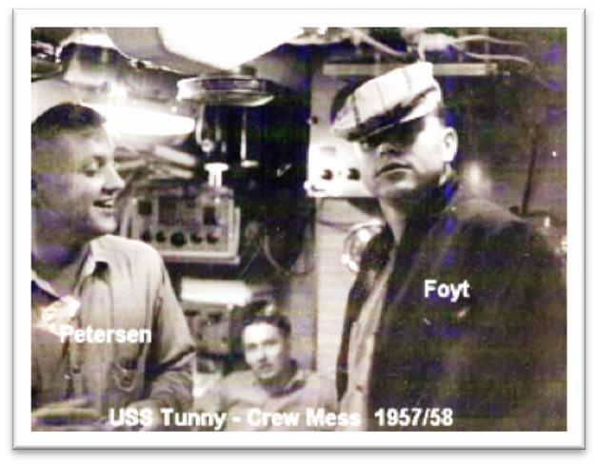
serving on Tunny, Elo became qualified in submarines, and was promoted to Engineman Third Class. Elo made three more Regulus Deterrent Patrols for a total of four (#1 through #4). He was promoted to Engineman Second Class in June 1960. In the following September, Foyt was discharged from the Navy. He returned to Texas and worked as a diesel engine repairman on locomotives for Point Comfort & Northern Railroad (PCN) until he retired. Elo Henry Foyt, Jr., resides in Edna, Texas, with his wife, Georgia, not too far from where he was born in the small town of Fort Ben, just southwest of Houston, Texas.
and made two Regulus Deterrent Patrols while on the Tunny. Bob was separated from the Navy in December 1959 and he returned to California. Bob Block now resides in Mount Vernon, Washington. His wife of 60 years, Barb, passed away in August 2017.
Photos shown are of Elo with Sonarman James C. Petersen in Tunny’s crews mess and the other was taken at Kuhio Beach, Waikiki, Territory of Hawaii, sometime in 1959. Left to right are Engineman Robert “Bob” Block of Sacramento, California, Yeoman and author Raymond “Ski” Olszewski, and Engineman Elo Henry Foyt, Jr.
Robert Jay Block came to the Tunny from submarine school in 1957 and served on Tunny as an Engineman Third Class. “Bob” Block qualified in submarines on the Tunny

John Joseph Jenkins, Jr., had the responsibility of securing the After Torpedo Room Hatch during the removal of the Ronquil’s Panther. JJ’s extended bio can be found in Chapter Thirteen.

Edward Casper Karamol’s role was assisting the Chiselers during the Ronquil Panther Raid. Edward Casper Karamol was born on 12 May 1939 in Springfield, Lucas County, Ohio, to Casper and Edith Anna (née Hall) Karamol. Casper and Edith raised four sons. Edward was the second and when he turned 17, he enlisted in the Navy and volunteered for submarine service. After graduating from the Enlisted Submarine Basic Training School, New London, Connecticut, Electrician’s Mate Fireman Apprentice “Ed” Karamol reported to the Tunny (SSG 282) at the Submarine Base, Pearl Harbor, Territory of Hawaii. That is Ed Karamol posing for the photo in one of Tunny’s engine rooms. While serving on the Tunny, Karamol was promoted to Fireman.

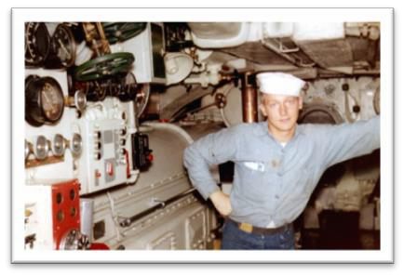
He qualified in submarines and was promoted to Electrician’s Mate Third Class Petty Officer. He made Tunny’s second Regulus Deterrent Strike patrol and participated in the Ronquil’s Panther Acquisition Team. On 20 April 1960, Ed Karamol was transferred to Treasure Island, California, where he received his discharge from the Navy and returned to civilian life. He returned to Ohio, where he married his high school sweetheart, Sandy Kuresz. While Ed worked as an electrician for American Shipbuilding in Toledo and later as an
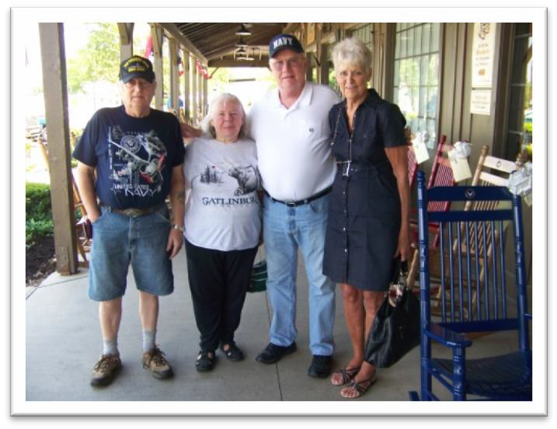
industrial engineer, Sandy and Ed raised two sons and a daughter, and adopted their granddaughter. Ed retired from a seat belt manufacturing company in April 2000 and resides in Monclavo, Ohio. Ed and Sandy travel around the country in their mobile home and attend Tunny reunions. At home in Monclavo, Ohio,
One story about Ed Karamol happened during one of Tunny’s port
visits to Midway Island for fuel. While the Tunny was being replenished, several of the crew walked from the pier to the Enlisted Men’s club on base. On the way, gooney birds and their cian, which could be seen by the thousands, were sitting around in droves. After a few beers at the club, the Tunny crewmen returned to the pier and during the walk back, Ed, who was a somewhat small-framed person grabbed one of the many gooney bird chicks by the neck and held it up with his arm extended. A base Chief Petty Officer, who was a rather large person, saw the encounter. He walked up to Ed and grabbed Ed by his neck in a similar manner and lifted him up off the ground. There the two were, a uniformed Navy chief holding Karamol by the neck with Ed’s arm still extended holding the chick by the neck. Looking at Ed, the Chief asked “How do you like it?” Shown in the photo is an image grabbed off the Internet of a gooney bird chick or albatross chick.
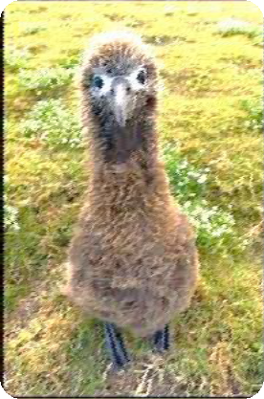
Ed works on repairing older cars and as a side business, delivers cars to clients in the Cleveland area. On our road trips from Minnesota to Pittsburgh, Pennsylvania, I and my high school sweetheart, Vicki, stop and have lunch with Ed and Sandy. We can attest that Sandy continues to take very good care of Ed. She is without a doubt, the most caring, nicest and sweetest person, and it is evident that she is the one that “keeps Ed on a zero bubble.”
Page 313

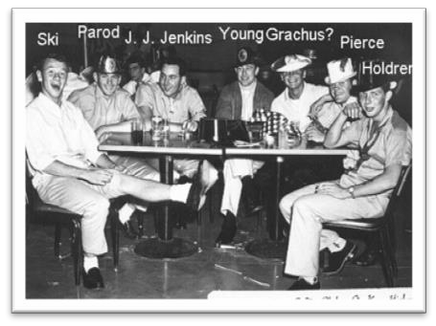
Garth Fred Miller’s role in the acquisition of the Ronquil Panther was to detain the Ronquil’s Topside Watch. Fred also conducted a successful reconnaissance mission to identify how the Ronquil’s Panther was mounted to the sub’s sail. Garth Frederick Miller was born 14 April 1939 in Boston, Massachusetts, to Emery and Lulu (née Alexander) Miller, who raised two sons while Emery worked as an optician in Boston. The family moved to Los Angeles, California in 1947 when Garth was eight years old. The younger of the two sons, Garth graduated from Mark Keppel High School and enlisted in the Navy on 17 April 1956, three days after his 17th birthday. Miller’s first submarine assignment was the Bream (SSK 243), which he reported to in 1956. He qualified on the Bream, served aboard until 1957, and volunteered to become a Guided Missileman. He was sent to the Guided Missile School, Dam Neck, Virginia, graduated, and reported to the Tunny in 1958. While on the Tunny, Fred Miller made Regulus Deterrent Patrols #1 and #2. In 1959, Miller participated in the acquisition of the Ronquil’s mascot. He was caught during the first attempt, was
shaved and given a warning not to try it again. Fred Miller was transferred off the Tunny in February 1960. He received his discharge from the Navy and settled in Covina, California, where he worked as an electronics technician/test engineer/department manager for Aerojet Electrosystems Corporation. He retired in 2002 and traveled around the United States in his motorhome between 2007 and 2012 using Henderson, Nevada, as his home base. He lives at 282 Windsong Echo Drive in Henderson.

Raymond Vance “Ski” Olszewski was responsible for securing the Ronquil’s Conning Tower Hatch. The operations required the efforts of both Charles J. Bonner and Ski because the shore power line ran through the hatch.

Donald Carl Parod volunteered to secure the Ronquil’s After Battery Hatch during the removal of Panther effigy. Don Parod was born on 18 March 1938 in Downers Grove, Illinois, a Chicago suburb, to Carl F. and Loretta E. (née Bangart) Parod. Carl worked as a milling machine operator for a telephone manufacturer while the couple raised two sons, Donald and Theodore. The Arizona Republic newspaper of Phoenix reported on 23 April 1957 that Donald C. Parod was among those who graduated in March from Navy Boot Camp, San Diego, California. He was sent to Submarine School, New London, Connecticut, and reported to his first submarine, the Tunny (SSG 282) as a Radioman Seaman on 29 March 1958. While on Tunny, Parod made Tunny’s first historic Regulus Deterrent Patrol in 1958, was promoted to Radioman Third Class, and became qualified in submarines. He was the After-Battery Hatch “Sitter” who kept the Ronquil crew below during the raid on 17 April 1959. Don Parod played on Tunny’s intramural

football team. He conducted two more Regulus Deterrent Patrols for a total of three while on Tunny. He was promoted to Radioman Second Class, and in November 1960, decided to take his discharge from the Navy rather than re-enlist. He was transferred off Tunny to return to civilian life. Donald Carl Parod settled in Phoenix, Arizona, met and married Stan-Lee (née Thompson) who gave him a son and two daughters. He was owner and president of Canyon State Excavating and Underground Company and served as fire commissioner for the Fountain Hills Fire Department. While residing in Fountain Hills, northeast of Scottsdale, Donald Carl Parod departed on Eternal Patrol on 9 November 1994.
The photo shows left to right, Tunny shipmates Yeoman Olszewski, Radioman Donald Carl Parod, Engineman “JJ” Jenkins, Torpedoman John Reginald Young, possibly Seaman Apprentice Kenneth Grachus, Engineman William “Billy” Pierce, and Fireman Apprentice Duane Holdren enjoying some relaxing moments at the Pearl Harbor Enlisted Men’s Club on Kam Highway, Territory of Hawaii.

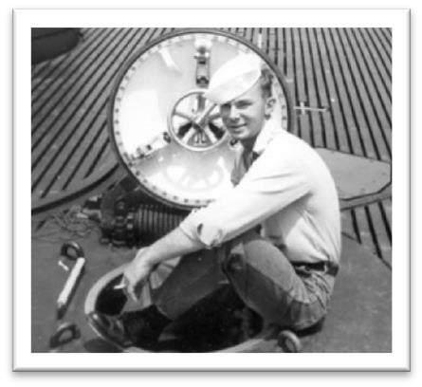
Thomas Samuel Samuelsen, Jr. performed as a Sitter on the Ronquil’s Forward Torpedo Room Hatch during the Ronquil Panther Stealing Raid. Thomas Samuel Samuelsen was born 31 July 1938 in Brooklyn, New York, to Thomas, Sr., and Alice Sylvia (née Anderson) Samuelsen. Thomas, Sr. emigrated from Norway and according to the 1940 U.S. Census, was earning a living as a mechanic for Edison Electric Company at the time
when Tom, Jr. was born. Tom’s father also joined the Navy and served during World War II in a Navy Construction Battalion (SeaBees). Tom graduated from Glen Cove High School in 1956, and enlisted in the Navy with aspirations to serve in submarines. Tom Samuelsen enlisted in the Navy on
9 January 1958 with his dad taking him to the Brooklyn Induction Center. After boot camp, Tom reported to the Basic Enlisted Submarine School, New London, Connecticut. On 13 February 1959, Seaman Samuelsen reported to the Tunny, which was in port at the Submarine Base, Pearl Harbor,
Territory of Hawaii. While serving on Tunny, Samuelsen
became an Electronics Technician Seaman, participated in establishing the Tunny Tiger as the sub’s first mascot, and became a qualified submariner, taking six months to qualify. Tom did not stay on Tunny very long; he was transferred off on 17 August 1959 to the Naval Training Center, Bainbridge, Maryland, to attend Naval Academy Preparatory School. He was promoted to Third Class. When he failed to attain a “B” in English, he ended up being transferred to the Bang (SS 385), homeported in New London.

After serving on Bang for eight months, Samuelsen received orders to report to Nuclear Power School. Tom received orders to the Tinosa (SSN 606), a new construction nuclear-powered fast attack submarine, where he became part of the ET Gang. During his time on Tinosa, Tom got to know many of the crew of Tinosa’s sister ship, the Thresher (SSN 593). On 10 April 1963 during a dive to “test depth,” a weld in a seawater system in the engineering spaces ruptured, which caused major flooding. Thresher became the first US nuclear submarine to be lost at sea.. Tom says in the memoirs he is writing, “Since the Tinosa and Thresher crews were so close; Thresher’s sinking hit us very hard and personal.” After serving on Tinosa, Electronics

Technician First Class, ET1(SS) Samuelson was honorably discharged from the Navy and returned to civilian life, working for Electric Boat in Groton, Connecticut. Tom Samuelsen was offered a position with Oak Ridge National Laboratory in Tennessee where he worked for a couple of years as an electronics technician. He then worked for IBM at various locations and projects until he retired as an advisory curriculum developer. In his retirement, Tom works in his home woodworking shop, making old-time wooden children’s toys. He lives in Fairfield, Pennsylvania (near Harrisburg), with his wife, Carol (née Terlikosky), who gave him a son and a daughter. Tom is also writing his memoirs for his family. He shared his initial drafts and in them are several sea stories recalling his time on Tunny and Tinosa. Tom is also active in the TriState Chapter of the USSVI as treasurer. That photo of Tom sitting in Tunny’s forward torpedo room hatch is like the one he sat on during the Ronquil Panther Raid.
The photo shows the forward torpedo room’s hatch similar to that of the Ronquil’s which “Sam” secured during the Panther raid in 1959. The photo was taken by Carl T. “CT” Hill, a former radioman who served on Tunny from 1959 to 1960. Hill, of Wilkes-Barre, Pennsylvania, made five Regulus Deterrent Patrols on Tunny. Carl Hill departed on Eternal Patrol on 4 October 2015 while residing in Wilkes-Barre, Pennsylvania.
An article appeared in the Honolulu Star-Advertiser on 17 August 1959 titled, “Two to Enter Annapolis Prep”, and identified Samuelsen and Roy Allen Hansen., also of the Tunny, as the two scholars. Hansen was a Guided Missileman Seaman from Longview, Washington, who served on Tunny for a short six months in 1959.

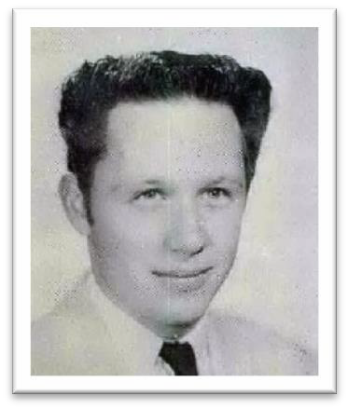
Keith James “Buzz” Sawyer used a 16-pound hammer and a chisel to successfully remove the Ronquil’s Panther statue that was welded to the sub’s superstructure. Keith James Sawyer was born on 4 September 1938 in Sacramento, California, to James and Elasan (née Porter) who made a living farming in Galt, California. Keith was the couple’s only child. Five days after Keith graduated from Galt High School in the class of 1956 (photo), he enlisted in the Navy and volunteered for submarine service. He graduated from Enlisted Basic Submarine Training, New London, Connecticut in November 1956. On 8 December 1956, Seaman Apprentice Sawyer reported to the Tunny (SSG 282) while it was operating out of Port Hueneme, California. While serving on the
Tunny, Keith became a fireman and he qualified in submarines. He was promoted to Engineman Third Class in June 1958 and made Tunny’s first Regulus Deterrent Patrol. .

On 14 August 1959, Sawyer was transferred off Tunny and decided to take his discharge from the Navy and return to civilian life. Between 1964 and 1968, Keith worked for the San Joaquin County Sheriff’s Office. Keith told me that he had family of Swiss descent who had developed a large plantation in Mangal Island, Philippines, and wanted him to join them. Keith resigned from the Sheriff’s Office and headed to the Philippines. His wife, Rochelle, whom he married in February 1960, and their son, Chris, joined him. The Philippine government offered him a concession to log off and plant behind the plantation. The location was Tawi Island, between the Sulu and Celebes Seas. Keith was in charge of the logging operation that turned into a cattle ranch. Under the Laurel-Langley Agreement, Keith and his family were given the same rights as
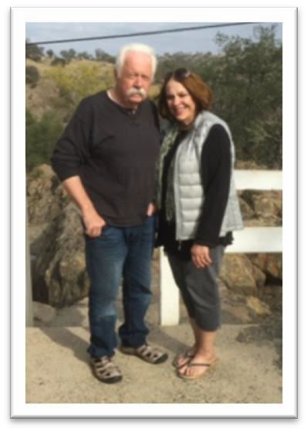
a Philippines citizen, except the right to vote. They lived in Zamboanga and with five years to complete the project. Sawyer, with the same “can-do” spirit he had on Tunny, completed the job in three years’ time. Tunny was in the Philippines at the same time as Sawyer, operating out of Subic Bay, several hundred miles north. After Filipino President Ferdinand Marcos voided the Agreement, Keith decided to return to the United States. He returned to his job at the same Sheriff’s Office and settled in Stockton, California. He worked as a homicide detective and took a position with the district attorney’s office. He bought a small vineyard raising Tokay grapes and shipped his fruit to Gallo while he continued to work in law enforcement. Keith Sawyer retired, sold the winery, and moved to Seldovia, about 120 miles south of Anchorage, Alaska.

While there, he engaged in logging and commercial fishing. Later
he became involved in the Prudhoe Bay oilfield. He said he finally retired on 9 December 2009 after working for 27 years. He returned to the property he had invested in earlier near Lodi, California, and planted a new 20-acre vineyard that is full of Cabernet vines. He enjoys playing the “snow bird” — summers in Alaska and winters in California. Keith and his wife Rochelle are shown in a recent photograph.

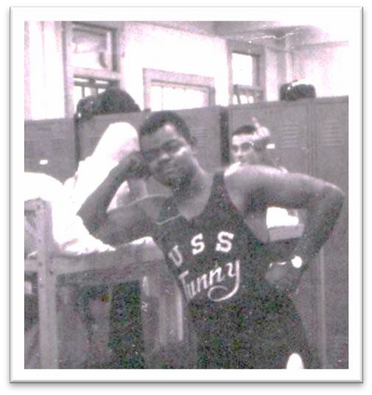
Charles Mason “Smitty” Smith was responsible for securing the Ronquil’s After Engine Room Hatch during the removal of the Ronquil’s Panther effigy.
By some accounts, Charles Mason (“Smitty”) Smith served a hitch in the U.S. Army as a paratrooper before he enlisted in the Navy. “JJ” remembers seeing Smitty’s paratrooper insignia worn with his dolphins on his uniform during one of the few inspections we had on Tunny. “Smitty” had reported on 3 March 1959 to the Tunny from Submarine School, New London, Connecticut, as a Radioman Seaman. Smitty became involved as a participant in the establishment of Tunny’s first mascot, the Tunny Tiger. Smitty played on Tunny’s Intramural Football Team and made four Regulus Deterrent Patrols (#2 through #5). During the return trip from Tunny’s second Regulus patrol, he came down with appendicitis and was transferred to the Naval Hospital,
Adak, Alaska, for treatment. A month later, he was returned to the Tunny via Treasure Island. In May 1962, Radioman Second Class Smith ended up back at Treasure Island, but this time he received a separation from his enlistment and returned to civilian life. Smitty attended the 1999 Reunion in Pittsburgh, Pennsylvania, and the 2003 Tunny Reunion in Reno, Nevada. At the time, he stayed in his motor home. He has not been seen or heard of since.
Photo shown above is Smitty wearing a Tunny’s sports shirt. In the background Dave Whittlesey can be seen displaying a “fickle finger of fate.”

The Ronquil’s Panther Acquisition Team (then and some now) photo gallery and Tunny’s Panther/Tiger mascot at various times and conditions.
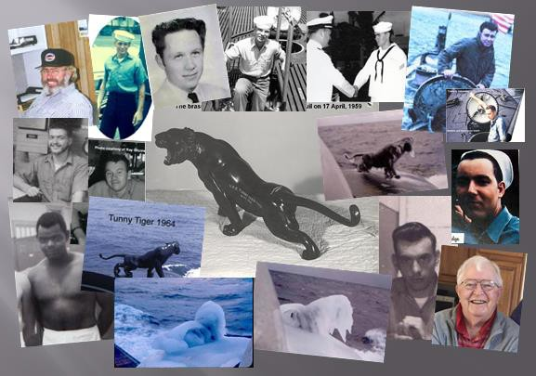
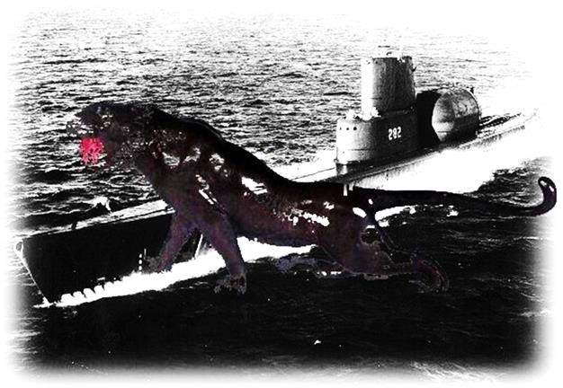

Tunny, the Tiger!

